|  |  |  |  |  |  |  |  |  |  |  |  |  |  |  |  |  |  |  |  |  |  |  |  |  |  |  |  |  |  |  |  |  |  |  |  |  |  |  |  |  |  |  |  |  |  |  |  |  |  |  |  |  |  |  |  |  |  |  |  |  |  |  |  |  |  |  |  |  |  |  |  |  |  |  |  |  |  |  |  |  |  |  |  |  |  |  |  |  |  |  |  |  |  |  |  |  |  |  |  |  |  |  |  |  |  |  |  |  |  |  |  |  |  |  |  |  |  |  |  |  |  |  |  |  |  |  |  |  |  |  |  |  |  |  |  |  |  |  |  |  |  |  |  |  |  |  |  |  |  |  |  |  |  |  |  |  |  |  |  |  |  |  |  |  |  |  |  |  |  |  |  |  |  |  |  |  |  |  |  |  |  |  |  |  |  |  |  |  |  |  |  |  |  |  |  |  |  |  |  |  |  |  |  |  |  |  |  |  |  |  |  |  |  |  |  |  |  |  |  |  |  |  |  |  |  |  |  |  |  |  |  |  |  |  |  |  |  |  |  |  |  |  |  |  |  |  |  |  |  |  |  |  |  |  |  |  |  |  |  |  |  |  |  |  |  |  |  |  |  |  |  |  |  |  |  |  |  |  |  |  |  |  |  |  |  |  |  |  |  |  |  |  |  |  |  |  |  |  |  |  |  |  |  |  |  |  |  |  |  |  |  |  |  |  |  |  |  |  |  |  |  |  |  |  |  |  |  |  |  |  |  |  |  |  |  |  |  |  |  |  |  |  |  |  |  |  |  |  |  |  |  |  |  |  |  |  |  |  |  |  |  |  |  |  |  |  |  |  |  |  |  |  |  |  |  |  |  |  |  |  |  |  |  |  |  |  |  |  |  |  |  |  |  |  |  |  |  |  |  |  |  |  |  |  |  |  |  |  |  |  |  |  |  |  |  |  |  |  |  |  |  |  |  |  |  |  |  |  |  |  |  |  |  |  |  |  |  |  |  |  |  |  |  |  |  |  |  |  |  |  |  |  |  |  |  |  |  |  |  |  |  |  |  |  |  |  |  |  |  |  |  |  |  |  |  |  |  |  |  |  |  |  |  |  |  |  |  |  |  |  |  |  |  |  |  |  |  |  |  |  |  |  |  |  |  |  |  |  |  |  |  |  |  |  |  |  |  |  |  |  |  |  |  |  |  |  |  |  |  |  |  |  |  |  |  |  |  |  |  |  |  |  |  |  |  |  |  |  |  |  |  |  |  |  |  |  |  |  |  |  |  |  |  |  |  |  |  |  |  |  |  |  |  |  |  |  |  |  |  |  |  |  |  |  |  |  |  |  |  |  |  |  |  |  |  |  |  |  |  |  |  |  |  |  |  |  |  |  |  |  |  |  |  |  |  |  |  |  |  |  |  |  |  |  |  |  |  |  |  |  |  |  |  |  |  |  |  |  |  |  |  |  |  |  |  |  |  |  |  |  |  |  |  |  |  |  |  |  |  |  |  |  |  |  |  |  |  |  |  |  |  |  |  |  |  |  |  |  |  |  |  |  |  |  |  |  |  |  |  |  |  |  |  |  |  |  |  |  |  |  |  |  |  |  |  |  |  |  |  |  |  |  |  |  |  |  |  |  |  |  |  |  |  |  |  |  |  |  |  |  |  |  |  |  |  |  |  |  |  |  |  |  |  |  |  |  |  |  |  |  |  |  |  |  |  |  |  |  |  |  |  |  |  |  |  |  |  |  |  |  |  |  |  |  |  |  |  |  |  |  |  |  |  |  |  |  |  |  |  |  |  |  |  |  |  |  |  |  |  |  |  |  |  |  |  |  |  |  |  |  |  |  |  |  |  |  |  |  |  |  |  |  |  |  |  |  |  |  |  |  |  |  |  |  |  |  |  |  |  |  |  |  |  |  |  |  |  |  |  |  |  |  |  |  |  |  |  |  |  |  |  |  |  |  |  |  |  |  |  |  |  |  |  |  |  |  |  |  |  |  |  |  |  |  |  |  |  |  |  |  |  |  |  |  |  |  |  |  |
| --- | --- | --- | --- | --- | --- | --- | --- | --- | --- | --- | --- | --- | --- | --- | --- | --- | --- | --- | --- | --- | --- | --- | --- | --- | --- | --- | --- | --- | --- | --- | --- | --- | --- | --- | --- | --- | --- | --- | --- | --- | --- | --- | --- | --- | --- | --- | --- | --- | --- | --- | --- | --- | --- | --- | --- | --- | --- | --- | --- | --- | --- | --- | --- | --- | --- | --- | --- | --- | --- | --- | --- | --- | --- | --- | --- | --- | --- | --- | --- | --- | --- | --- | --- | --- | --- | --- | --- | --- | --- | --- | --- | --- | --- | --- | --- | --- | --- | --- | --- | --- | --- | --- | --- | --- | --- | --- | --- | --- | --- | --- | --- | --- | --- | --- | --- | --- | --- | --- | --- | --- | --- | --- | --- | --- | --- | --- | --- | --- | --- | --- | --- | --- | --- | --- | --- | --- | --- | --- | --- | --- | --- | --- | --- | --- | --- | --- | --- | --- | --- | --- | --- | --- | --- | --- | --- | --- | --- | --- | --- | --- | --- | --- | --- | --- | --- | --- | --- | --- | --- | --- | --- | --- | --- | --- | --- | --- | --- | --- | --- | --- | --- | --- | --- | --- | --- | --- | --- | --- | --- | --- | --- | --- | --- | --- | --- | --- | --- | --- | --- | --- | --- | --- | --- | --- | --- | --- | --- | --- | --- | --- | --- | --- | --- | --- | --- | --- | --- | --- | --- | --- | --- | --- | --- | --- | --- | --- | --- | --- | --- | --- | --- | --- | --- | --- | --- | --- | --- | --- | --- | --- | --- | --- | --- | --- | --- | --- | --- | --- | --- | --- | --- | --- | --- | --- | --- | --- | --- | --- | --- | --- | --- | --- | --- | --- | --- | --- | --- | --- | --- | --- | --- | --- | --- | --- | --- | --- | --- | --- | --- | --- | --- | --- | --- | --- | --- | --- | --- | --- | --- | --- | --- | --- | --- | --- | --- | --- | --- | --- | --- | --- | --- | --- | --- | --- | --- | --- | --- | --- | --- | --- | --- | --- | --- | --- | --- | --- | --- | --- | --- | --- | --- | --- | --- | --- | --- | --- | --- | --- | --- | --- | --- | --- | --- | --- | --- | --- | --- | --- | --- | --- | --- | --- | --- | --- | --- | --- | --- | --- | --- | --- | --- | --- | --- | --- | --- | --- | --- | --- | --- | --- | --- | --- | --- | --- | --- | --- | --- | --- | --- | --- | --- | --- | --- | --- | --- | --- | --- | --- | --- | --- | --- | --- | --- | --- | --- | --- | --- | --- | --- | --- | --- | --- | --- | --- | --- | --- | --- | --- | --- | --- | --- | --- | --- | --- | --- | --- | --- | --- | --- | --- | --- | --- | --- | --- | --- | --- | --- | --- | --- | --- | --- | --- | --- | --- | --- | --- | --- | --- | --- | --- | --- | --- | --- | --- | --- | --- | --- | --- | --- | --- | --- | --- | --- | --- | --- | --- | --- | --- | --- | --- | --- | --- | --- | --- | --- | --- | --- | --- | --- | --- | --- | --- | --- | --- | --- | --- | --- | --- | --- | --- | --- | --- | --- | --- | --- | --- | --- | --- | --- | --- | --- | --- | --- | --- | --- | --- | --- | --- | --- | --- | --- | --- | --- | --- | --- | --- | --- | --- | --- | --- | --- | --- | --- | --- | --- | --- | --- | --- | --- | --- | --- | --- | --- | --- | --- | --- | --- | --- | --- | --- | --- | --- | --- | --- | --- | --- | --- | --- | --- | --- | --- | --- | --- | --- | --- | --- | --- | --- | --- | --- | --- | --- | --- | --- | --- | --- | --- | --- | --- | --- | --- | --- | --- | --- | --- | --- | --- | --- | --- | --- | --- | --- | --- | --- | --- | --- | --- | --- | --- | --- | --- | --- | --- | --- | --- | --- | --- | --- | --- | --- | --- | --- | --- | --- | --- | --- | --- | --- | --- | --- | --- | --- | --- | --- | --- | --- | --- | --- | --- | --- | --- | --- | --- | --- | --- | --- | --- | --- | --- | --- | --- | --- | --- | --- | --- | --- | --- | --- | --- | --- | --- | --- | --- | --- | --- | --- | --- | --- | --- | --- | --- | --- | --- | --- | --- | --- | --- | --- | --- | --- | --- | --- | --- | --- | --- | --- | --- | --- | --- | --- | --- | --- | --- | --- | --- | --- | --- | --- | --- | --- | --- | --- | --- | --- | --- | --- | --- | --- | --- | --- | --- | --- | --- | --- | --- | --- | --- | --- | --- | --- | --- | --- | --- | --- | --- | --- | --- | --- | --- | --- | --- | --- | --- | --- | --- | --- | --- | --- | --- | --- | --- | --- | --- | --- | --- | --- | --- | --- | --- | --- | --- | --- | --- | --- | --- | --- | --- | --- | --- | --- | --- | --- | --- | --- | --- | --- | --- | --- | --- | --- | --- | --- | --- | --- | --- | --- | --- | --- | --- | --- | --- | --- | --- | --- | --- | --- | --- | --- | --- | --- | --- | --- | --- | --- | --- | --- | --- | --- | --- | --- | --- | --- | --- | --- | --- | --- | --- | --- | --- | --- | --- | --- | --- | --- | --- | --- | --- | --- | --- | --- | --- | --- | --- | --- | --- | --- | --- | --- | --- | --- | --- | --- | --- | --- | --- | --- | --- | --- | --- | --- | --- | --- | --- | --- | --- | --- | --- | --- | --- | --- | --- | --- | --- | --- | --- | --- | --- | --- | --- | --- | --- | --- | --- | --- | --- | --- | --- | --- | --- | --- | --- | --- | --- | --- | --- | --- | --- | --- | --- | --- | --- | --- | --- | --- | --- | --- | --- | --- | --- | --- | --- | --- | --- | --- | --- | --- | --- | --- | --- | --- | --- | --- | --- | --- | --- | --- | --- | --- | --- | --- | --- | --- | --- | --- | --- | --- | --- | --- | --- | --- | --- | --- | --- | --- | --- | --- | --- | --- | --- | --- | --- | --- | --- | --- | --- | --- | --- | --- |
| **1 Description of the Use Case**  **1.1 Name of Use Case**   |  |  |  | | --- | --- | --- | | ***Use Case Identification*** | | | | ***ID*** | ***Domain(s)*** | ***Name of Use Case*** | |  | 61968 Part 3, 5, 8, and 9 Messaging and 62325-21 | DER Trip after Distribution Circuit Fault Message Use Case |   **1.2 Version Management**   |  |  |  |  |  |  |  |  | | --- | --- | --- | --- | --- | --- | --- | --- | | ***Version Management*** | | | | | | | | | ***Changes / Version*** | | ***Date*** | ***Name Author(s) or Committee*** | ***Domain Expert*** | ***Area of Expertise / Domain / Role*** | ***Title*** | ***Approval Status***  *draft, for comments, for voting, final* | | 0.1 | 1/27/2022 | WG-13, WG14 | Chuck DuBose | Power System Engineer | Principle Engineer | draft for internal discussion | | 0.2 | 3/3/2022 | WG-21 | Margaret Goodrich | Software Engineer | Software Engineer |  | | 0.3 | 3/9/2022 | WG-13, WG14 | Chuck DuBose | Power System Engineer | Principle Engineer | Added additional use case for tripping inverters | | 0.4 | 3/25/2022 | WG-13, WG14 | Chuck DuBose  Margaret Goodrich | Power System Engineer  Software Engineer | Principle Engineer  Software Engineer | Corrected Use Cases | | 0.5 | 6/1/2022 | WG-13, WG14 | Chuck DuBose | Power System Engineer | Principle Engineer | Added justification for disconnecting DER Inverter,  Added additional use cases for Untelemetered IED Status | | 0.6 | 6/24/2022 | WG-13, WG14 | Chuck DuBose  Margaret Goodrich | Power System Engineer  Software Engineer | Principle Engineer  Software Engineer | Accepted corrections and added Sequence Diagrams | | 1.0 | 7/1/2022 | WG13, WG14 | Chuck DuBose  Margaret Goodrich | Power System Engineer  Software Engineer | Principle Engineer  Software Engineer | Final corrections and added UML Diagrams |   **1.3 Scope and Objectives of Use Case**   |  |  | | --- | --- | | ***Scope and Objectives of Use Case*** | | | ***Related business case*** | Reference IEC 61968-9, End Device Control Messages; IEC61968-5, DER Group Messages; IEC61968-3, Unplanned Outage Message; IEC 61968-8, Interfaces for customer operations | | ***Scope*** | This case covers the requirements for a message to remove residential or bulk DER sources by group or individually from a distribution circuit which has been tripped due to a fault. | | ***Objective*** | To define how the current Connect/Disconnect messages for meters and group DER are used and to define the need for a new message to command a single DER.  Creation of a message to disconnect a single DER from all or portions of a distribution circuit in response to a fault detected on the circuit. This would require the creation of a new message to command a single DER. |   **1.4 Narrative of Use Case**   |  | | --- | | ***Narrative of Use Case*** | | ***Short description*** *– max 3 sentences* | | Disconnect all customers with DER and Bulk DER from faulted circuit after protection device tripping and reconnect after circuit restoration. If the DER is residential, the disconnect happens with the EndDeviceControl message for the Meter or group DER disconnect message. If the disconnect is for the Bulk DER, the DER Group Disconnect message is used. | | ***Complete description*** | | **Fault Impedance Background:**  Fault impedance is the impedance between the energized equipment and ground. The Fault impedance plus the culmination of the source impedance of all online generators along with all parallel lines and transformers of the transmission system to the distribution bus plus the series line impedance to the fault location determine the voltage at the fault. Fault impedance is dependent on what comes in contact with energized equipment. High impedance faults are extensively an overhead line problem.  Typically, an energized wire in contact with a grounded wire or equipment has no fault impedance. An overhead phase wire lying on the ground is generally determined to have a low fault impedance. But a phase wire lying on snow, asphalt, or very dry sand, which are not good conductors, may have a very high fault impedance. Small tree branches or foliage brushing against the line may result in a high impedance fault. High impedance faults cannot be predicted or measured using today’s technology, therefore any fault must be assumed to be a high impedance fault. The significance of a high impedance fault is the high impedance reduces the fault current and thus does not depress the line voltage as much as a very well-grounded fault. Once the protecting device upline from the fault trips through all its reclosing cycles to lockout, the fault is normally considered to be cleared.  If the voltage at the fault is high enough to exceed the ride through settings of the DER inverters on the circuit, then the inverters will stay online through the fault and after the protective device locks out. Most of the time, even in conditions of high impedance faults and once the interrupting device on the circuit trips, the voltage will drop further to a value below the inverter trip setting and all of the inverters will trip offline. In cases where the distribution circuit has a high penetration of DER, there are enough sources to supply fault current at a voltage magnitude above the DER ride though threshold. The DER inverters are fooled into thinking they are still within operating guidelines and continue keep the circuit energized. This condition can create hazards to equipment and people. Also, during large storms, customers will hook up small generators to run necessary appliances and some will forget to disconnect their main breaker.  It would be better to trip all DER after a fault than to risk personal injury. This DER tripping will be accomplished through the use of the EndDeviceControl message for the residential meters and the DERGroup disconnect for the Bulk DER. In areas where it is mandated to trip the DER, a disconnect message may be sent to the residential inverters instead of disconnecting the meters.  **Tripping DERs:**  The DER disconnect is accomplished by sending a “disconnect” message (i.e., an EndDeviceControl message) to the meter to disconnect the customers which have DER or in some cases, send a disconnect directly to the DER inverter. Disconnecting the meter would allow the customer to use his DER to serve his house load during the outage without trying to energize entire sections of the isolated circuit. Using the meter to disconnect DER should require an acknowledgement from the meter that it had disconnected. Figure 3 shows the contents of the EndDeviceControl and Figure 4 shows the control code for disconnecting. Isolation of the DER bulk units is accomplished by sending a ‘disconnect” message (i.e., a DERGroup message) to the DERs on the circuit. Figure 5 shows the contents of the DERGroup control.  Some states require the DER Inverter to be tripped instead of the meter. In areas where it is mandated to trip the DER, the DERGroup message may be used to disconnect the inverters for both bulk DER and residential DER. Sending a disconnect signal to the residential DER inverters is precautionary in case the anti-islanding detection fails to disconnect the inverter during a fault. This is a public safety issue. If finer control is needed to trip DER inverters individually, the EndDeviceControl connect/disconnect message will be used. Individual DER are considered as an End Device. There are positive reasons for tripping meters to remove DER and directly tripping the DER inverter as mentioned above. Directly tripping the DER inverter can be accomplished through the DERMS. The ADMS architecture provides a direct connection to the DERMS. The DER groups can be organized through the DERMS to disconnect an entire feeder or a portion of a feeder. This would make the group tripping more organized along the different zones of protection of each fault isolating device.  **Tripping Logic:**  The logic below is a proposal and may reflect certain capabilities not existing in current ADMS systems. Whether a message to trip the DERs is sent automatically or manually is not being required here. It should be noted that groups of DER would need to be set up using the DERGroup creation message so the trip DER Group message can be sent quickly in response to fault to alleviate the risk of accidents. If meter disconnecting is used, then The DER groups should NOT include the residential DER units. In addition, the ADMS will need to implement the ability to trip the residential meters on the feeder so the meters of residential DER can be isolated.  Since the arrangement of customers to distribution circuits can be fluid due to temporary switching, there would be a need for additional logic to control which residential and bulk DER would need to be tripped based on temporary switching. Assuming this logic indicates the need to disconnect a single bulk DER unit, the Connect/Disconnect EndDeviceControl message would be used to control a single DER unit to be disconnected. None of the above are capabilities of the ADMS but are to be considered as possible future enhancements of a ADMS and would be required to implement this use case.  Using Figure 1 below, if a fault occurs causing the circuit breaker to trip, all bulk DER or meters on the circuit should be automatically sent a message to disconnect. This is the area within the blue box.  If a fault occurs causing the Recloser on Figure 1 to trip, all DER or meters within the red box should be automatically sent a message to disconnect.  Since there is no telemetering of fuse status, outage management will determine that one of the fuses on the laterals has blown. Messages will be sent from the ADMS to the DERs via the DERMS on the isolated lateral to trip. This information could be gleaned from the customer information system. Customers call in during lights out events and the outage management system uses this information to determine where to send personnel along with the isolation device which isolated the fault. The Outage Isolation Equipment defined in the Unplanned Outage Message could be used to indicate that a specific fuse has blown on a circuit. Figure 2 shows the content of the Unplanned Outage Message.  DER Groups can be organized around the smallest set of DER needed to be disconnected. For instance, the groups can be organized for all of the lateral fuses. If the recloser trips, then multiple DER groups can be disconnected to remove all DER in the section of the circuit isolated by the recloser.  If there is no way to determine the extent of the fault, the fault could be treated as loss of the entire circuit and all DER could be removed from the circuit. It would not be wise to trip meters in this case. Removing the DER from the full circuit would be better. It becomes the choice of safety over customer economics.  **Restoration:**  Restoration occurs in two ways. For circuits without the connectivity to energize portions of the circuit to another source such as an adjacent circuit, the entire disconnected section would have to be energized after repairs. Under these conditions, all DER disconnected after the fault, would be restored in bulk. For circuits with ties to adjacent circuits or sections of the circuit, parts of the disconnected circuit could be restored as the fault is isolated by switching or disconnecting jumpers and tie switches could be closed. There is an example of the “normally open tie” on Figure 1. This tie switch connects one circuit to another so portions of each circuit could remain energized during certain outage conditions.  **Reconnecting DERs:**  The DER reconnect is accomplished by sending a “connect” message DER to the circuit. To accomplish restoration, EndDeviceControl connect messages sent to the residential Meters in cases where meters were used to isolate the residential DER. DERGroup and the EndDeviceControl connect messages for individual bulk DERs would need to be executed to connect the DER location by group or individually as needed. In cases where the Inverters were disconnected for the residential DER, DERGroup connect messages would be sent to both residential and bulk DER. |   **1.5 General Remarks**   |  | | --- | | ***General Remarks*** | | Distribution Management systems are becoming very sophisticated in their ability to indicate to the operator what the real time extent of a feeder may be along with energization state of the entire feeder. This could be used to automate the extent of the meters being disconnected after a fault isolation. This should be considered in future ADMS design. |   **2 Diagrams of Use Case**   |  | | --- | | ***Diagram of Use Case*** | | Figure 1 – Distribution Circuit Diagram | | Figure 2 – Outage Isolation Equipment section of the Unplanned Outage XSD | | Figure 3 – EndDeviceControl XSD (Used for Meter, DER & DER Group Control) | | Figure 4 – EndDeviceControl Codes (the codes use for these messages) | |  | | Figure 5 – EndDeviceEvent XSD (used for Meter, DER & DER Group Events) | | Section 6.1 – All Sequence Diagrams | | Section 6.2 – All UML Diagrams |   **3 Technical Details**  **3.1 Actors: People, Systems, Applications, Databases, the Power System, and Other Stakeholders**   |  |  |  |  | | --- | --- | --- | --- | | ***Actors*** | | | | | ***Grouping (Community)*** | | ***Group Description*** | | |  | |  | | | ***Actor Name***  *see Actor List* | ***Actor Type***  *see Actor List* | ***Actor Description***  *see Actor List* | ***Further information specific to this Use Case*** | | Fault Isolating Device |  | Circuit breaker, sectionalizer, fuse or recloser |  | | ADMS | Advanced Distribution Management System | Distribution control system which integrates all functions of a distribution management system and outage management system into a single integrated package. |  | | CIS | Role | Customer Information System |  | | Customer |  |  |  | | DSO | Role | Distribution System Operator |  | | WMS | Role | Work Management System |  | | Meter | Customer Smart Meter | Customer smart meter |  | | IED |  | Intelligent Electronic Device controlling the fault isolating device |  | | DER Inverters | Distributed Energy Resource Inverter | The DC to AC inverter unit connecting distributed energy resources to the AC grid. This includes photo voltaic panels, car chargers, battery chargers, and generators which may be located on a residential or commercial customer premise or bulk solar or wind connected to the low voltage power distribution feeders. |  | | DERMS | Distributed Energy Resource Management System | Software system between the ADMS and the DER in the field which aggregates groups of DER. The DERMS takes requests from the ADMS and disperses it to the individual and group DERs as needed and collects the details of the DERs and produces totals based on the grouping. |  | | Bulk DER | Bulk Distributed Energy Resource | Energy Resources such as a large solar and wind farm connected to the distribution system |  | | MMS | Meter Management System | The software responsible for the management of the customer meters. |  |   **3.2 Preconditions, Assumptions, Post condition, Events**   |  |  |  |  | | --- | --- | --- | --- | | ***Use Case Conditions*** | | | | | ***Actor/System/Information/Contract*** | ***Triggering Event*** | ***Pre-conditions*** | ***Assumption*** | | ADMS |  |  | ADMS should have accurate feeder models with detailed switch and customer locations.  ADMS and Meter systems must be capable of sending and receiving standard CIM messaging.  The ADMS must maintain groups of DER disconnected by protective devices. The groups in the DERMS must be aligned with the ADMS DER groups. | | DSO |  |  | DSO must manually maintain switching device state for non-telemetered switches, fuses, etc. |   **4 Step by Step Analysis of Use Case**   |  |  |  |  |  |  | | --- | --- | --- | --- | --- | --- | | **Scenario Conditions** | | | | | | | **No.** | **Scenario Name** | **Primary Actor** | **Triggering Event** | **Pre-Condition** | **Post-Condition** | | 4.1 | Telemetered IED Status - Disconnect Meter and Bulk DER | IED/DMS/DSO/Meter | Meter Trips | Fault is isolated | Fault is cleared | | 4.2 | Untelemetered IED Status - Disconnect Meter and Bulk DER | IED/DMS/CIS/DSO/Meter | Meter Trips | Fault is isolated | Fault is cleared | | 4.3 | Telemetered IED Status - Disconnect Residential DER Inverter and Bulk DER Inverter | IED/DMS/DSO/DER Inverter | Device Trips | Fault is isolated | Fault is cleared | | 4.4 | Untelemetered IED Status - Disconnect Residential DER Inverter and Bulk DER Inverter | IED/DMS/CIS/DSO/ DER Inverter | Meter Trips | Fault is isolated | Fault is cleared |   **4.1 Steps –** **Telemetered IED Status – Disconnect Meter and Bulk DER**   |  |  | | --- | --- | | ***Scenario Name:*** | | | ***Step No.*** | ***Event*** | ***Name of Process/ Activity*** | ***Description of Process/ Activity*** | ***Information Producer (Actor)*** | ***Information Receiver (Actor)*** | ***Message Type (Verb/Noun)*** | |  | | 1 |  | Protective device trip | Fault Isolating Device trips | IED |  |  | | 2 |  | Telemetered SCADA status | The status of the fault isolating device is sent to the ADMS SCADA | IED | ADMS | Proprietary Isolating Device Status | | 3 |  | Create switching plan | ADMS uses the UnplannedOutage and creates the SwitchingPlan | ADMS | ADMS | SwitchingPlan message | | 4 |  | ADMS Notifies DSO of switching plan | The ADMS notifies the DSO of the clearance SwitchingPlan | ADMS | DSO | Internal ADMS display alarm | | 5 |  | Meter group selection | DSO analyses the clearance switching plan and selects proper meter tripping group for the faulted part of the circuit. | DSO | ADMS | None – Look-up switching plan and analyse | | 6 |  | DSO initiates “disconnect” control to the list of meters | DSO selects command to send “disconnect” to the MMS for the meters in the selected group | DSO | ADMS | EndDeviceControl message | | 7 |  | ADMS sends "disconnect” control to the list of meters to MMS | ADMS sends an EndDeviceControl message to “disconnect” the list of meters to the MMS system | ADMS | MMS | EndDeviceControl message | | 8 |  | MMS sends the “disconnect” control to the list of meters. | MMS sends the “disconnect” command to the meters in the list | MMS | Meter | Proprietary message | | 9 |  | Meters send “disconnect” event to MMS | Meters send a “disconnect” Ack event to the MMS. | Meter | MMS | Proprietary message | | 10 |  | MMS sends “disconnect” event to ADMS | The MMS sends the meter “disconnect” EndDeviceEvent message to the ADMS. | MMS | ADMS | EndDeviceEvent message | | 11 |  | MMS sends notification to customers on the “disconnect” list | MMS sends a CustomerNotification to the CIS which forwards the correspondence to the customer to whom the meter is assigned. The correspondence should explain that the disconnect is a result of a circuit fault. | MMS | CIS | CustomerNotification message | | 12 |  | ADMS determines outage extent | ADMS determines which section of a circuit has faulted. | ADMS | ADMS | None | | 13 |  | ADMS sends DERMS outage extent | ADMS sends an EndDeviceEvent message containing the isolated circuit information to the DERMS (DERs to Disconnect) | ADMS | DERMS | EndDeviceEvent message | | 14 |  | DERMS sends “disconnect” to Bulk DER | DERMS sends an EndDeviceEvent message to “disconnect” the DER Group which contains the Bulk DER located in the isolated part of the circuit. | DERMS | Bulk DER | EndDeviceControl message | | 15 |  | Bulk DER sends “disconnect” event to DERMS | The Bulk DER sends an EndDeviceEvent message acknowledging the "disconnect” event to the DERMS | Bulk DER | DERMS | EndDeviceEvent message | | 16 |  | DERMS sends Bulk DER “disconnect” event to ADMS | DERMS sends an EndDeviceEvent message acknowledging the "disconnect” event to the ADMS | DERMS | ADMS | EndDeviceEvent message | | 17 |  | Repair | Faulted part of circuit is repaired and reenergized | WMS | ADMS | Multiple FLISR, work request and work order messages are processed | | 18 |  | Close protective device | The status of the fault isolating device is sent to the ADMS SCADA. | IED | ADMS | Proprietary Isolating Device Status | | 19 |  | Initiate “connect” to the list of meters | DSO selects command to send “connect” message to the ADMS for transmission. to the MMS for the meters in selected group | DSO | ADMS | None – Manual Process | | 20 |  | ADMS sends "connect” control to the list of meters to MMS | ADMS sends an EndDeviceControl message to “connect” the list of meters to the MMS system | ADMS | MMS | EndDeviceControl message | | 21 |  | MMS sends the “connect” control to the list of meters. | MMS sends the “connect” command to the meters in the list | MMS | Meter | Proprietary connect message | | 22 |  | Meters send “connect” event to MMS | Meters send a “connect” Ack event to the MMS. | Meter | MMS | Proprietary connect message | | 23 |  | MMS send “connect” to ADMS | The MMS sends the meter “connect” EndDeviceEvent message to the ADMS. | MMS | ADMS | EndDeviceEvent message | | 24 |  | MMS sends notification to customers on the “connect” list | MMS sends a CustomerNotification to the CIS which forwards the correspondence to the customer to whom the meter is assigned. The correspondence should explain that the connect is a result of a circuit fault restoration. | MMS | CIS | CustomerNotification message | | 25 |  | ADMS Determines Restoration Extent | ADMS determines which section of a circuit has restored. | ADMS | ADMS | None | | 26 |  | ADMS sends DERMS restored info | ADMS sends an EndDeviceEvent message containing the re-energized circuit information to the DERMS (DERs to Connect) | ADMS | DERMS | EndDeviceEvent message | | 27 |  | DERMS sends “connect” control to Bulk DER | DERMS sends an EndDeviceEvent message to “connect” the DER Group which contains the Bulk DER located in the isolated part of the circuit. | DERMS | Bulk DER | EndDeviceControl message | | 28 |  | Bulk DER sends “connect” event to DERMS | The Bulk DER sends an EndDeviceEvent message acknowledging the "connect” event to the DERMS | Bulk DER | DERMS | EndDeviceEvent message | | 29 |  | DERMS sends Bulk DER “connect” to ADMS | DERMS sends an EndDeviceEvent message acknowledging the "connect” event to the ADMS | DERMS | ADMS | EndDeviceEvent message |   **4.2 Steps – Untelemetered IED Status - Disconnect Meter and Bulk DER**   |  |  | | --- | --- | | ***Scenario Name:*** | | | ***Step No.*** | ***Event*** | ***Name of Process/ Activity*** | ***Description of Process/ Activity*** | ***Information Producer (Actor)*** | ***Information Receiver (Actor)*** | ***Message Type (Verb/Noun)*** | |  | | 1 |  | Protective device trip | Fault Isolating Device trips | IED |  |  | | 2 |  | Reporting the outage | Customer interacts with IVR or customer representative | Customer | CIS | Customer reports Outage | | 3 |  | Receives outage information | The ADMS(OMS) analyses the TroubleTicket and determines an outage occurred. | CIS | ADMS | Create TroubleTicket message | | 4 |  | Untelemetered Outage Analysis | The ADMS analyses the TroubleTickets(s) and creates an UnplannedOutage message which contains the tripped fault isolation device | ADMS | ADMS | Create UnplannedOutage message | | 5 |  | Create switching plan | ADMS uses the UnplannedOutage and creates the SwitchingPlan | ADMS | ADMS | SwitchingPlan message | | 6 |  | ADMS Notifies DSO of switching plan | The ADMS notifies the DSO of the clearance SwitchingPlan | ADMS | DSO | Internal ADMS display alarm | | 7 |  | Meter group selection | DSO analyses the clearance switching plan and selects proper meter tripping group for the faulted part of the circuit. | DSO | ADMS | None – Look-up switching plan and analyse | | 8 |  | DSO initiates “disconnect” control to the list of meters | DSO selects command to send “disconnect” to the MMS for the meters in the selected group | DSO | ADMS | EndDeviceControl message | | 9 |  | ADMS sends "disconnect” control to the list of meters to MMS | ADMS sends an EndDeviceControl message to “disconnect” the list of meters to the MMS system | ADMS | MMS | EndDeviceControl message | | 10 |  | MMS sends the “disconnect” control to the list of meters. | MMS sends the “disconnect” command to the meters in the list | MMS | Meter | Proprietary message | | 11 |  | Meters send “disconnect” event to MMS | Meters send a “disconnect” Ack event to the MMS. | Meter | MMS | Proprietary message | | 12 |  | MMS sends “disconnect” event to ADMS | The MMS sends the meter “disconnect” EndDeviceEvent message to the ADMS. | MMS | ADMS | EndDeviceEvent message | | 13 |  | MMS sends notification to customers on the “disconnect” list | MMS sends a CustomerNotification to the CIS which forwards the correspondence to the customer to whom the meter is assigned. The correspondence should explain that the disconnect is a result of a circuit fault. | MMS | CIS | CustomerNotification message | | 14 |  | ADMS determines outage extent | ADMS determines which section of a circuit has faulted. | ADMS | ADMS | None | | 15 |  | ADMS sends DERMS outage extent | ADMS sends an EndDeviceEvent message containing the isolated circuit information to the DERMS (DERs to Disconnect) | ADMS | DERMS | EndDeviceEvent message | | 16 |  | DERMS sends “disconnect” to Bulk DER | DERMS sends an EndDeviceEvent message to “disconnect” the DER Group which contains the Bulk DER located in the isolated part of the circuit. | DERMS | Bulk DER | EndDeviceControl message | | 17 |  | Bulk DER sends “disconnect” event to DERMS | The Bulk DER sends an EndDeviceEvent message acknowledging the "disconnect” event to the DERMS | Bulk DER | DERMS | EndDeviceEvent message | | 18 |  | DERMS sends Bulk DER “disconnect” event to ADMS | DERMS sends an EndDeviceEvent message acknowledging the "disconnect” event to the ADMS | DERMS | ADMS | EndDeviceEvent message | | 19 |  | Repair | Faulted part of circuit is repaired and reenergized | Crew Member | ADMS | WorkOrder message | | 20 |  | ADMS Alerts DSO of repair | ADMS alerts the DSO alerting him that the circuit repair is complete. | ADMS | DSO | Incident message | | 21 |  | Initiate “connect” to the list of meters | DSO selects command to send “connect” message to the ADMS for transmission to the MMS for the meters in selected group | DSO | ADMS | None – Manual Process | | 22 |  | ADMS sends "connect” control to the list of meters to MMS | ADMS sends an EndDeviceControl message to “connect” the list of meters to the MMS system | ADMS | MMS | EndDeviceControl message | | 23 |  | MMS sends the “connect” control to the list of meters. | MMS sends the “connect” command to the meters in the list | MMS | Meter | Proprietary connect message | | 24 |  | Meters send “connect” event to MMS | Meters send a “connect” Ack event to the MMS. | Meter | MMS | Proprietary connect message | | 25 |  | MMS send “connect” to ADMS | The MMS sends the meter “connect” EndDeviceEvent message to the ADMS. | MMS | ADMS | EndDeviceEvent message | | 26 |  | MMS sends notification to customers on the “connect” list | MMS sends a CustomerNotification to the CIS which forwards the correspondence to the customer to whom the meter is assigned. The correspondence should explain that the connect is a result of a circuit fault restoration. | MMS | CIS | CustomerNotification message | | 27 |  | ADMS Determines Restoration Extent | ADMS determines which section of a circuit has restored. | ADMS | ADMS | None | | 28 |  | ADMS sends DERMS restored info | ADMS sends an EndDeviceEvent message containing the re-energized circuit information to the DERMS (DERs to Connect) | ADMS | DERMS | EndDeviceEvent message | | 29 |  | DERMS sends “connect” control to Bulk DER | DERMS sends an EndDeviceEvent message to “connect” the DER Group which contains the Bulk DER located in the isolated part of the circuit. | DERMS | Bulk DER | EndDeviceControl message | | 30 |  | Bulk DER sends “connect” event to DERMS | The Bulk DER sends an EndDeviceEvent message acknowledging the "connect” event to the DERMS | Bulk DER | DERMS | EndDeviceEvent message | | 31 |  | DERMS sends Bulk DER “connect” to ADMS | DERMS sends an EndDeviceEvent message acknowledging the "connect” event to the ADMS | DERMS | ADMS | EndDeviceEvent message |   **4.3 Steps – Telemetered IED Status – Disconnect Residential DER Inverter and Bulk DER Inverter**   |  |  | | --- | --- | | ***Scenario Name:*** | | | ***Step No.*** | ***Event*** | ***Name of Process/ Activity*** | ***Description of Process/ Activity*** | ***Information Producer (Actor)*** | ***Information Receiver (Actor)*** | ***Information*** | | ***Exchanged*** | | 1 |  | Protective device trip | Fault Isolating Device trips | IED |  |  | | 2 |  | Telemetered SCADA status | The status of the fault isolating device is sent to the ADMS SCADA | IED | ADMS | Proprietary Isolating Device Status | | 3 |  | ADMS determines outage extent | ADMS determines which section of a circuit has faulted. | ADMS | ADMS | None | | 4 |  | ADMS sends DERMS outage extent | ADMS sends an EndDeviceEvent message containing the isolated circuit information to the DERMS (DERs to Disconnect) | ADMS | DERMS | EndDeviceEvent message | | 5 |  | DERMS sends “disconnect” to all DER inverters | DERMS sends an EndDeviceEvent message to “disconnect” the DER Group which contains all residential, commercial, and Bulk DER Inverters located in the isolated part of the circuit. | DERMS | DER Inverters | EndDeviceControl message | | 6 |  | DER inverter sends “disconnect” event to DERMS | The Bulk DER sends an EndDeviceEvent message acknowledging the "disconnect” event to the DERMS | DER Inverters | DERMS | EndDeviceEvent message | | 7 |  | DERMS sends all DER inverter “disconnect” event to ADMS | DERMS sends an EndDeviceEvent message acknowledging the "disconnect” event to the ADMS | DERMS | ADMS | EndDeviceEvent message | | 8 |  | Repair | Faulted part of circuit is repaired and reenergized | WMS | ADMS | Multiple FLISR, work request and work order messages are processed | | 9 |  | Close protective device | The status of the fault isolating device is sent to the ADMS SCADA. | IED | ADMS | Proprietary Isolating Device Status | | 10 |  | ADMS Determines Restoration Extent | ADMS determines which section of a circuit has restored. | ADMS | ADMS | None | | 11 |  | ADMS sends DERMS restored info | ADMS sends an EndDeviceEvent message containing the re-energized circuit information to the DERMS (DERs to Connect) | ADMS | DERMS | EndDeviceEvent message | | 12 |  | DERMS sends “connect” control to all DER | DERMS sends an EndDeviceEvent message to “connect” the DER Group which contains all residential, commercial, and Bulk DER inverters in the restored area. | DERMS | DER Inverters | EndDeviceControl message | | 13 |  | All DER inverters send “connect” event to DERMS | The Bulk DER sends an EndDeviceEvent message acknowledging the "connect” event to the DERMS | DER Inverters | DERMS | EndDeviceEvent message | | 14 |  | DERMS sends all DER inverter “connect” event to ADMS | DERMS sends an EndDeviceEvent message acknowledging the "connect” event to the ADMS | DERMS | ADMS | EndDeviceEvent message |   **4.4 Steps – Untelemetered IED Status – Disconnect Residential DER Inverter and Bulk DER Inverter**   |  |  | | --- | --- | | ***Scenario Name:*** | | | ***Step No.*** | ***Event*** | ***Name of Process/ Activity*** | ***Description of Process/ Activity*** | ***Information Producer (Actor)*** | ***Information Receiver (Actor)*** | ***Information*** | | ***Exchanged*** | | 1 |  | Protective device trip | Fault Isolating Device trips | IED |  |  | | 2 |  | Reporting the outage | Customer interacts with IVR or customer representative | Customer | CIS | Customer reports Outage | | 3 |  | Receives outage information | The ADMS(OMS) analyses the TroubleTicket and determines an outage occurred. | CIS | ADMS | Create TroubleTicket message | | 4 |  | Untelemetered Outage Analysis | The ADMS analyses the TroubleTickets(s) and creates an UnplannedOutage message which contains the tripped fault isolation device | ADMS | ADMS | Create UnplannedOutage message | | 5 |  | ADMS determines outage extent | ADMS determines which section of a circuit has faulted. | ADMS | ADMS | None | | 6 |  | ADMS sends DERMS outage extent | ADMS sends an EndDeviceEvent message containing the isolated circuit information to the DERMS (DERs to Disconnect) | ADMS | DERMS | EndDeviceEvent message | | 7 |  | DERMS sends “disconnect” to all DER inverters | DERMS sends an EndDeviceEvent message to “disconnect” the DER Group which contains all residential, commercial, and Bulk DER Inverters located in the isolated part of the circuit. | DERMS | DER Inverters | EndDeviceControl message | | 8 |  | DER inverter sends “disconnect” event to DERMS | The Bulk DER sends an EndDeviceEvent message acknowledging the "disconnect” event to the DERMS | DER Inverters | DERMS | EndDeviceEvent message | | 9 |  | DERMS sends all DER inverter “disconnect” event to ADMS | DERMS sends an EndDeviceEvent message acknowledging the "disconnect” event to the ADMS | DERMS | ADMS | EndDeviceEvent message | | 10 |  | Repair | Faulted part of circuit is repaired and reenergized | Crew Member | ADMS | WorkOrder message | | 11 |  | ADMS Alerts DSO of repair | ADMS alerts the DSO alerting him that the circuit repair is complete. | ADMS | DSO | Incident message | | 12 |  | ADMS Determines Restoration Extent | ADMS determines which section of a circuit has restored. | ADMS | ADMS | None | | 13 |  | ADMS sends DERMS restored info | ADMS sends an EndDeviceEvent message containing the re-energized circuit information to the DERMS (DERs to Connect) | ADMS | DERMS | EndDeviceEvent message | | 14 |  | DERMS sends “connect” control to all DER inverters | DERMS sends an EndDeviceEvent message to “connect” the DER Group which contains all residential, commercial, and Bulk DER inverters in the restored area. | DERMS | DER Inverters | EndDeviceControl message | | 15 |  | All DER inverters send “connect” event to DERMS | The Bulk DER sends an EndDeviceEvent message acknowledging the "connect” event to the DERMS | DER Inverters | DERMS | EndDeviceEvent message | | 16 |  | DERMS sends Bulk DER “connect” to ADMS | DERMS sends an EndDeviceEvent message acknowledging the "connect” event to the ADMS | DERMS | ADMS | EndDeviceEvent message |   **5 Information Exchanged**   |  |  |  | | --- | --- | --- | | ***Information Exchanged*** | | | | ***Name of Information Exchanged*** | ***Description of Information Exchanged*** | ***Requirements to information data***  ***R-ID*** | | Fault Information | Messages containing the customer outages, SCADA device status and switching orders to isolate the faulted area. This information assists the operator determine the extent of the outage in order to disconnect the proper DER Inverters |  | | EndDeviceControl | The messages exchanged to disconnect and reconnect the DER Inverters and Meters islanded during a fault. |  |   **6 Implementation Sequence & UML Diagrams**   |  | | --- | | **Sequence and UML Diagrams** | | The sequence diagram below illustrates the flow of the message between the systems. This diagram is used by the implementation team to develop the converters and adapters and the programs that will send and receive the message to implement the data exchange between the systems.  The UML diagram below illustrates the excerpt of the model that was used to generate the XSD message in the Figures below. | |

**6.1 Sequence Diagrams**

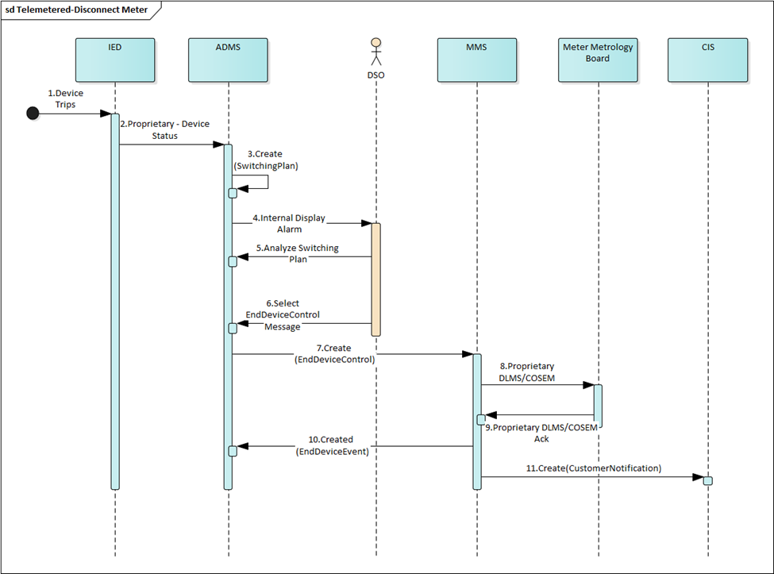

Table 4.1: Telemetered IED Status – Disconnect Meter and Bulk DER

Steps 1-11

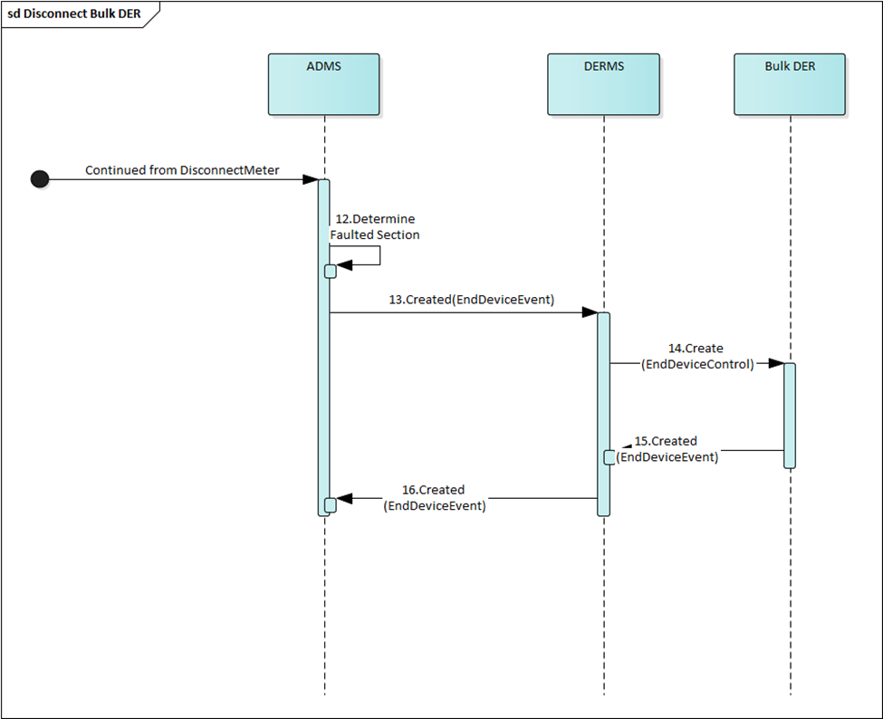

Table 4.1: Telemetered IED Status – Disconnect Meter and Bulk DER

Steps 12-16

(Same as 4.2 Steps 14-18)

There are sections of the use cases for the telemetered and untelemetered disconnect meter and bulk DER which are identical. The diagram for steps 12 – 16 in use case 4.1 are identical to steps 14 – 18 in use case 4.2.

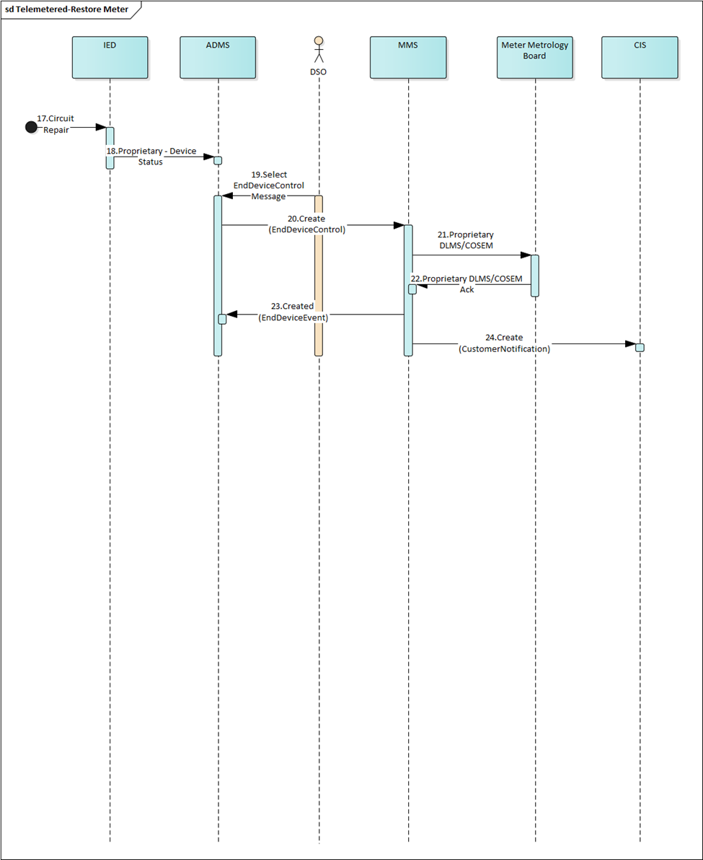

Table 4.1: Telemetered IED Status – Disconnect Meter and Bulk DER

Steps 17-24

Table 4.1: Telemetered IED Status – Disconnect Meter and Bulk DER

Steps 25-29

(Same as Table 4.2 Steps 27-31)

There are sections of the use cases for the telemetered and untelemetered disconnect meter and bulk DER which are identical. The diagram for steps 25 – 29 in use case 4.1 are identical to steps 27 – 31 in use case 4.2.

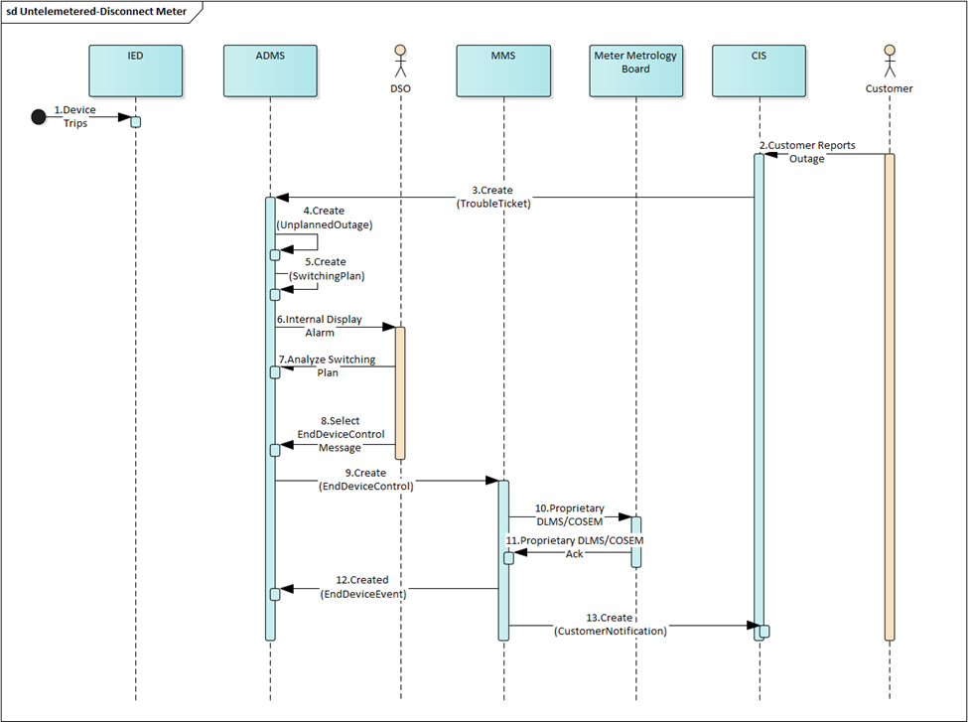

Table 4.2: Untelemetered IED Status - Disconnect Meter and Bulk DER

Steps 1-13

Table 4.2: Untelemetered IED Status - Disconnect Meter and Bulk DER

Steps 14-18

(Same as 4.1 Steps 12-16)

There are sections of the use cases for the telemetered and untelemetered disconnect meter and bulk DER which are identical. The diagram for steps 12 – 16 in use case 4.1 are identical to steps 14 – 18 in use case 4.2.

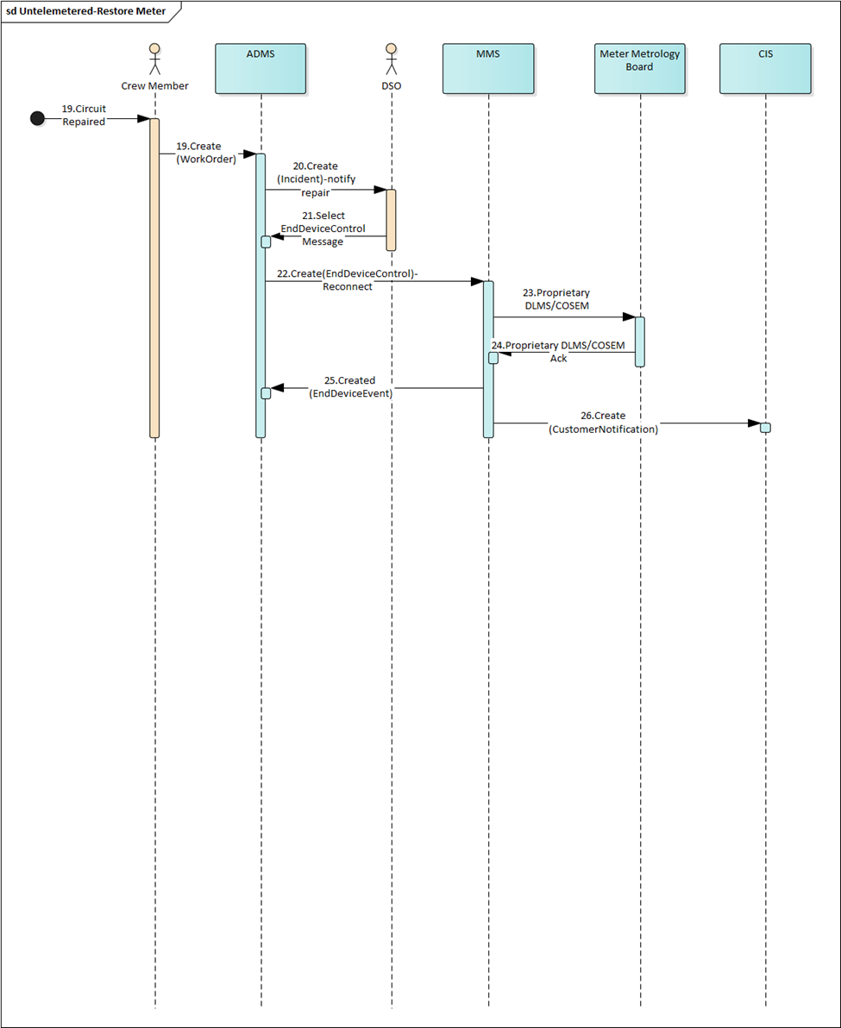

Table 4.2: Untelemetered IED Status - Disconnect Meter and Bulk DER

Steps 19-26

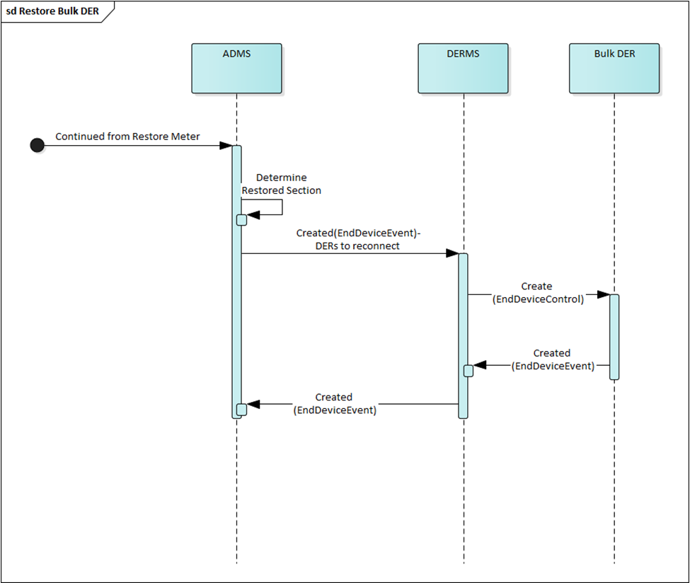

Table 4.2: Untelemetered IED Status - Disconnect Meter and Bulk DER

Steps 27-31

(Same as Table 4.1 Steps 25-29)

There are sections of the use cases for the telemetered and untelemetered disconnect meter and bulk DER which are identical. The diagram for steps 25 – 29 in use case 4.1 are identical to steps 27 – 31 in use case 4.2.

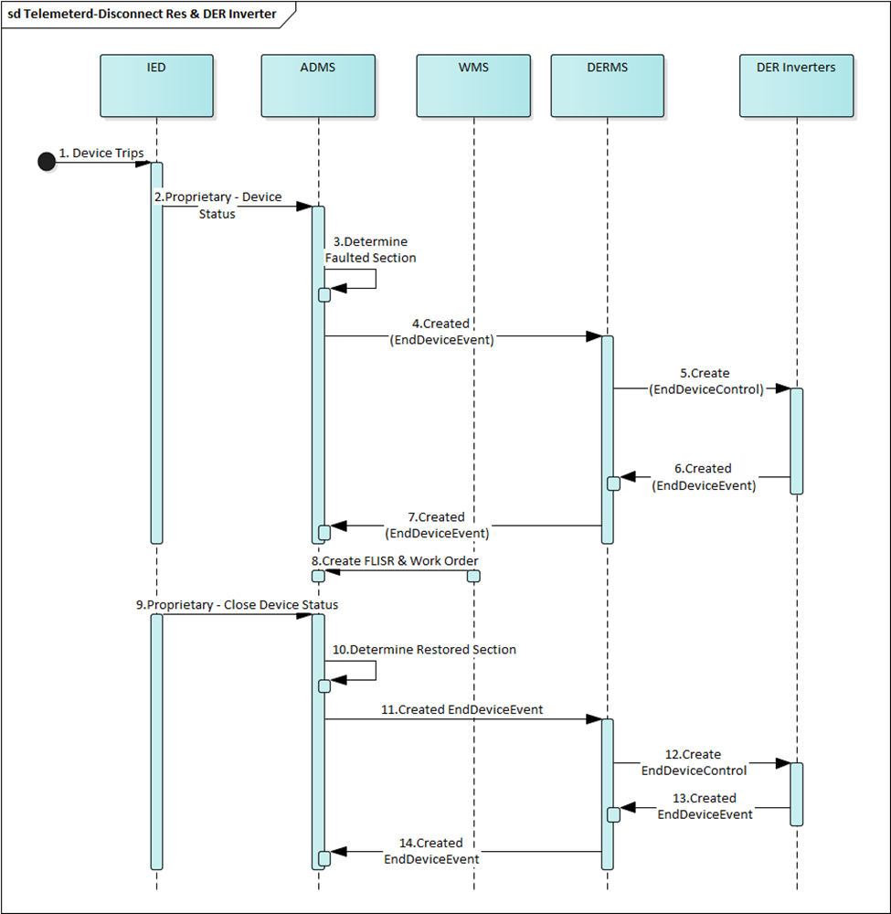

Table 4.3: Telemetered IED Status – Disconnect Residential DER and Bulk DER Inverters

All Steps

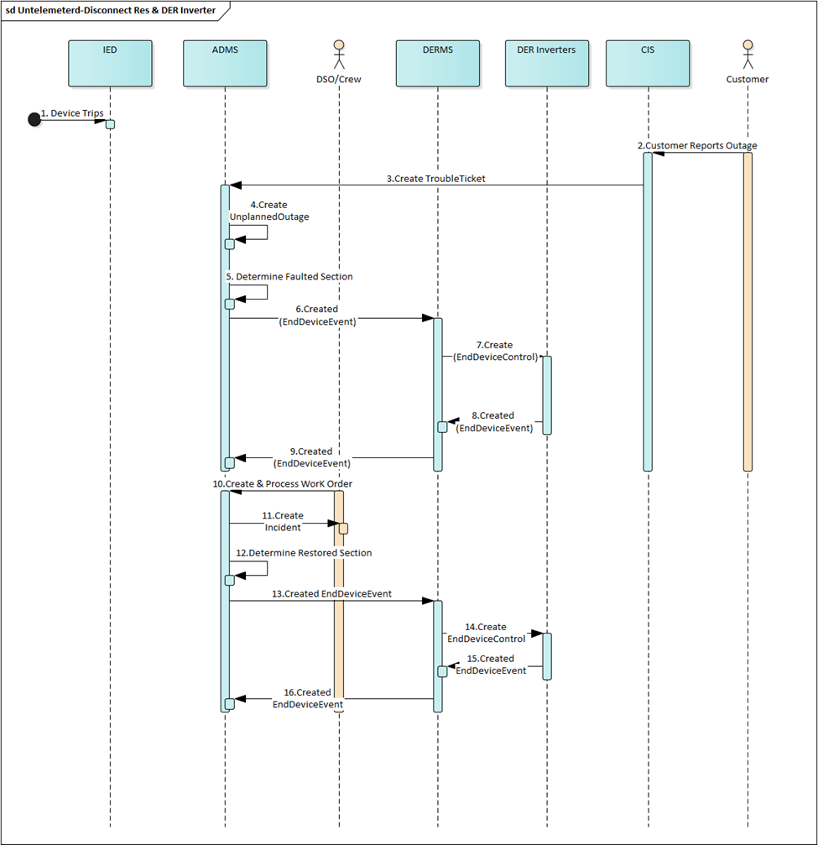

Table 4.4: Untelemetered IED Status – Disconnect Residential DER and Bulk DER Inverters

All Steps

**6.2 UML Diagrams**

The following diagrams are for the EndDeviceControl and EndDeviceEvent messages as shown in the XSDs below.

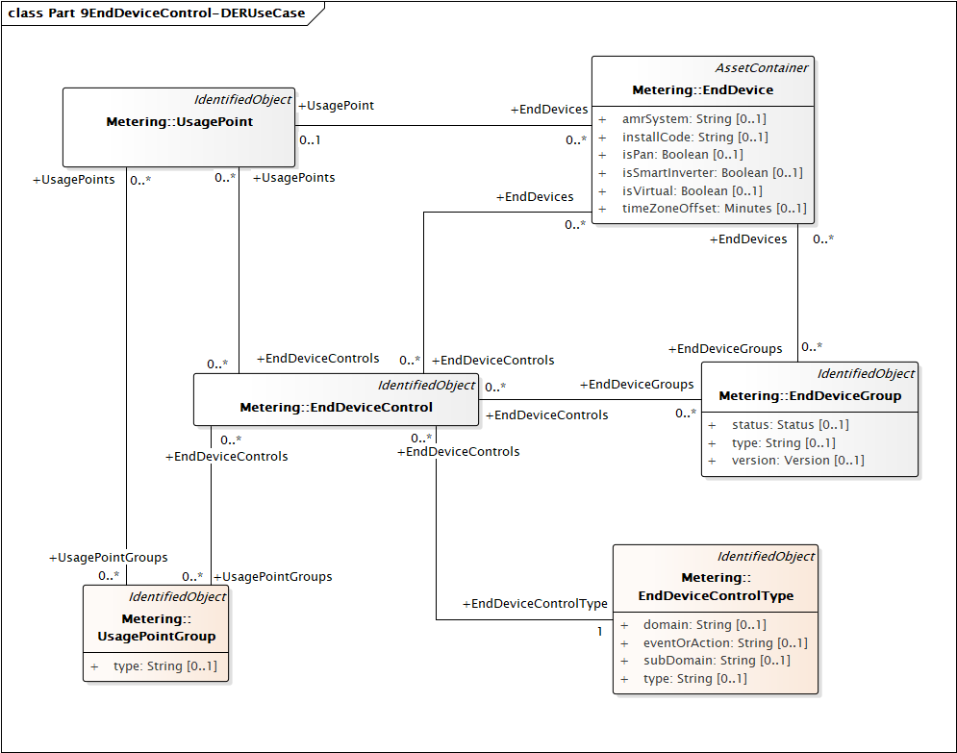

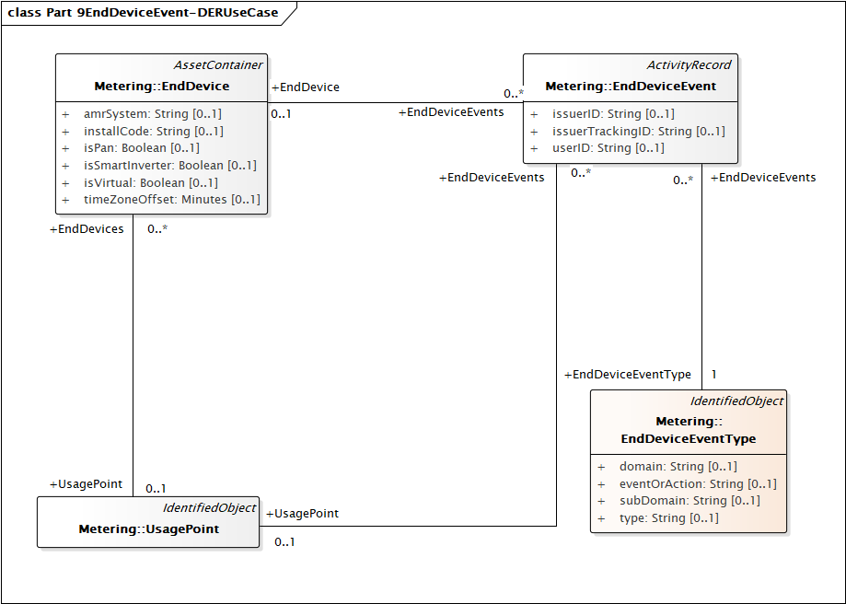

**7.0 Appendix 1: Figures**

Figure 1 – Distribution Circuit Diagram

Figure 2 – Isolation Equipment Fragment of the Unplanned Outage XSD

Figure 3 – EndDeviceControls

The above figure is the Control XSD for the Meter Connect/Disconnect and the individual/group DER or predetermined switch Connect/Disconnect.

Figure 4 – EndDeviceControl Codes

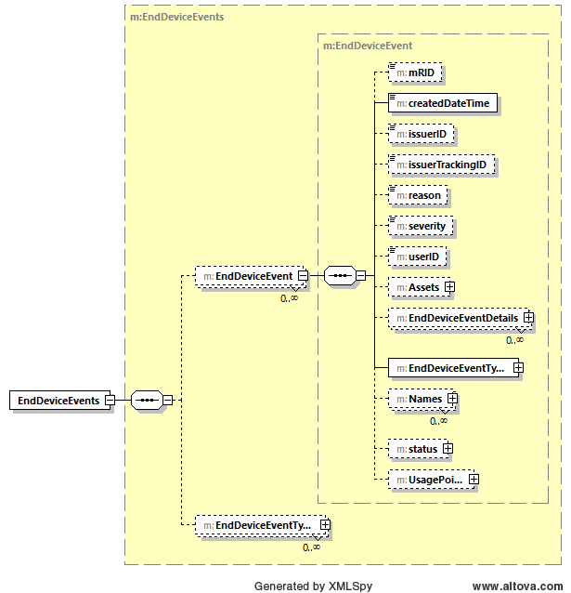

Figure 5 – EndDeviceEvents

The above figure is the Events XSD for the Meter Events/Acks and the individual/group DER Events/Acks or predetermined switch Events/Acks.