|  |  |  |  |  |  |  |  |  |  |  |  |  |  |  |  |  |  |  |  |  |  |  |  |  |  |  |  |  |  |  |  |  |  |  |  |  |  |  |  |  |  |  |  |  |  |  |  |  |  |  |  |  |  |  |  |  |  |  |  |  |  |  |  |  |  |  |  |  |  |  |  |  |  |  |  |  |  |  |  |  |  |  |  |  |  |  |  |  |  |  |  |  |  |  |  |  |  |  |  |  |  |  |  |  |  |  |  |  |  |  |  |  |  |  |  |  |  |  |  |  |  |  |  |  |  |  |  |  |  |  |  |  |  |  |  |  |  |  |  |  |  |  |  |  |  |  |  |  |  |  |  |  |  |  |  |  |  |  |  |  |  |  |  |  |  |  |  |  |  |  |  |  |  |  |  |  |  |  |  |  |  |  |  |  |  |  |  |  |  |  |  |  |  |  |  |  |  |  |  |  |  |  |  |  |  |  |  |  |  |  |  |  |  |  |  |  |  |  |  |  |  |  |  |  |  |  |  |  |  |  |  |  |  |  |  |  |  |  |  |  |  |  |  |  |  |  |  |  |  |  |  |  |  |  |  |  |  |  |  |  |  |  |  |  |  |  |  |  |  |  |  |  |  |  |  |  |  |  |  |
| --- | --- | --- | --- | --- | --- | --- | --- | --- | --- | --- | --- | --- | --- | --- | --- | --- | --- | --- | --- | --- | --- | --- | --- | --- | --- | --- | --- | --- | --- | --- | --- | --- | --- | --- | --- | --- | --- | --- | --- | --- | --- | --- | --- | --- | --- | --- | --- | --- | --- | --- | --- | --- | --- | --- | --- | --- | --- | --- | --- | --- | --- | --- | --- | --- | --- | --- | --- | --- | --- | --- | --- | --- | --- | --- | --- | --- | --- | --- | --- | --- | --- | --- | --- | --- | --- | --- | --- | --- | --- | --- | --- | --- | --- | --- | --- | --- | --- | --- | --- | --- | --- | --- | --- | --- | --- | --- | --- | --- | --- | --- | --- | --- | --- | --- | --- | --- | --- | --- | --- | --- | --- | --- | --- | --- | --- | --- | --- | --- | --- | --- | --- | --- | --- | --- | --- | --- | --- | --- | --- | --- | --- | --- | --- | --- | --- | --- | --- | --- | --- | --- | --- | --- | --- | --- | --- | --- | --- | --- | --- | --- | --- | --- | --- | --- | --- | --- | --- | --- | --- | --- | --- | --- | --- | --- | --- | --- | --- | --- | --- | --- | --- | --- | --- | --- | --- | --- | --- | --- | --- | --- | --- | --- | --- | --- | --- | --- | --- | --- | --- | --- | --- | --- | --- | --- | --- | --- | --- | --- | --- | --- | --- | --- | --- | --- | --- | --- | --- | --- | --- | --- | --- | --- | --- | --- | --- | --- | --- | --- | --- | --- | --- | --- | --- | --- | --- | --- | --- | --- | --- | --- | --- | --- | --- | --- | --- | --- | --- | --- | --- | --- | --- | --- | --- | --- | --- | --- | --- | --- | --- | --- | --- | --- | --- | --- | --- | --- | --- | --- | --- | --- | --- | --- | --- | --- | --- | --- | --- | --- | --- |
| **1 Description of the Use Case**  **1.1 Name of Use Case**   |  |  |  | | --- | --- | --- | | ***Use Case Identification*** | | | | ***ID*** | ***Domain(s)*** | ***Name of Use Case*** | |  | 61968-3 Outage messaging | Unplanned Outage Coordination from Transmission to Distribution |   **1.2 Version Management**   |  |  |  |  |  |  |  |  | | --- | --- | --- | --- | --- | --- | --- | --- | | ***Version Management*** | | | | | | | | | ***Changes / Version*** | | ***Date*** | ***Name Author(s) or Committee*** | ***Domain Expert*** | ***Area of Expertise / Domain / Role*** | ***Title*** | ***Approval Status***  *draft, for comments, for voting, final* | | 0.1 | 2/2/2022 | WG-13, WG14 | Chuck DuBose | Power System Engineer | Principle Engineer | draft for internal discussion | | 0.2 | 2/7/2022 | WG13, WG14 | Margaret Goodrich | Software Engineer | Software Engineer | Draft | | 0.3 | 2/10/2022 | WG-13, WG14 | Chuck DuBose | Power System Engineer | Principle Engineer | Additional edits | | 0.4 | 2/27/2022 | WG13, WG14 | Margaret  Goodrich | Software Engineer | Software Engineer | Review and edits | | 0.5 | 2/28/2022 | WG-13, WG14 | Chuck DuBose | Power System Engineer | Principle Engineer | Accepted all track changes and tweaks before presentation to the group | | 0.6 | 3/11/2022 | WG-13, WG14 | Chuck DuBose | Power System Engineer | Principle Engineer | Integrated requested changes for phase 1 | | 0.7 | 3/21/2022 | WG-13, WG14 | Chuck DuBose    Margaret Goodrich | Power System Engineer  Software Engineer | Principle Engineer  Software Engineer | Integrated changes, added clarifying text, removed comments, added Sequence diagrams, UML diagram and new XSD Message Profile Fragments | | 0.8 | 4/22/2022 | WG-13, WG14 | Chuck DuBose    Margaret Goodrich | Power System Engineer  Software Engineer | Principle Engineer  Software Engineer | Added comments on sub-transmission.  Add proposal to add fault current to the fault class and include it in the unplannedoutage message. | | 0.9 | 6/24/2022 | WG-13, WG14 | Chuck DuBose    Margaret Goodrich | Power System Engineer  Software Engineer | Principle Engineer  Software Engineer | Accepted changes and added sequence diagram | | 1.0 | 7/1/2022 | WG-13, WG14 | Chuck DuBose    Margaret Goodrich | Power System Engineer  Software Engineer | Principle Engineer  Software Engineer | Final changes |   **1.3 Scope and Objectives of Use Case**   |  |  | | --- | --- | | ***Scope and Objectives of Use Case*** | | | ***Related business case*** | IEC 61968-3, Unplanned Outage Message | | ***Scope*** | Coordinate unplanned outages from Transmission to Distribution | | ***Objective*** | Define Message(s) and formats required to complete the coordination of unplanned outages from Transmission to Distribution. |   **1.4 Narrative of Use Case**   |  | | --- | | ***Narrative of Use Case*** | | ***Short description*** *– max 3 sentences* | | This Use Case will explore the unplanned outage message flows currently in place in Transmission and Distribution and determine how these could be coordinated to provide a more reliable and resilient Grid. The current state of the Transmission and Distribution Grid is to be reviewed and possible information flows defined. Current and new messages and formats are identified to improve the coordination of the unplanned outages. The problem of disparate formats for communication are also explored and possible solutions are provided. | | ***Complete description*** | | **Power System Background:**  Distribution transformers may be connected to any transmission voltage level less than or equal to 345KV.  Predominantly, the bulk of distribution is served from the 230kv and below voltage levels. Since distribution substations must be near the load they serve, only some may be located in large transmission substations with multiple transmission voltage levels and multiple lines at multiple transmission voltage levels. More than likely, distribution substations are located on transmission lines which are routed through areas in proximity to the load. This would include sub transmission facilities. The sub-transmission system includes voltage levels at or below 69KV and radial lines at or below 138KV. Areas of light load are served by lower voltage lines, or a high voltage line routed in proximity of the load to provide support for network flows. In distribution stations with high load there are typically two distribution transformers serving the distribution bus. In the largest of distribution stations, the transformers are served from two different transmission lines so a single line fault will not take both distribution transformers out of service.    Sometimes to accomplish this when only a single transmission line goes through the station, circuit breakers are placed between the high side connection points of the two distribution transformers. This splits the transmission corridor into two different circuits. Economics does play a role in the design, so placing a transmission breaker at every station over the length of a transmission corridor would not be feasible. So, one or more line switches are used instead of a breaker so the faulted section can be isolated and one or both of the distribution transformers can be quickly returned to service.  Figure 1 shows one possible configuration of this arrangement. This diagram shows the layout of a distribution substation with breakers on the high voltage bus. The station has two distribution transformers connected to the transmission system. There are two transmission lines marked Supply line 1 and 2 which serve the station. Each transmission line in the station has its own breaker to isolate line faults. The HV bus tie breaker along with one of the Supply line breakers are used to isolate the transformer and half of the high side bus.  The distribution owner and operations staff would be very interested if either Supply line 1 or Supply line 2 were out. They may have direct telemetry on the transmission breakers. If so, they would know when one of the Supply line breakers or the HV bus tie breaker tripped. Take an example where Supply line 1 was one of several transmission lines connected in series on a single corridor back to a remote station where multiple transmission lines are terminated. A distribution system operator would not be interested in the lines in the remote station, but he would be very interested in the series of lines from the remote station back to its distribution station. There may be another line in the remote station which may create operating constraints to the distribution operator.  Distribution system operators need to know about the unplanned outages of the transmission and sub-transmission facilities that directly supply their distribution transformers or may put one or more feeders in a single contingency risk. For example, an unplanned outage may put a distribution system in a condition where loss of another single piece of equipment creates a lights-out event on their system. Due to experience, distribution operators know what transmission facilities create problems for their system.  The following transmission facilities, if lost, create a lights-out event on the distribution system:   * Transmission line and substation facilities which serve the distribution feeders * Distribution transformer(s) * Facilities directly adjacent to the distribution transformer * Substation bus the distribution transformer is attached to. * Transmission line outage if the transmission line is the only line that feeds the Distribution station   The following transmission facilities, if lost, create a lights-out event on the distribution system if another facility were out of service. This list may also include facilities that may only cause operating concerns, such as loading problems or volage problems on the distribution system. Examples of these are:   * Cases where the distribution substation is fed by two transmission lines coming from two different locations * All transmission lines in a corridor where the distribution substation is connected to a line on a long corridor made up of several lines in series * Loss of lines where distribution transformers are in multi-line substations. * Loss of line which may cause voltage drop or overload on additional facilities requiring shift in the distribution load.   Any loss of the above facilities will need to trigger one or more messages to the Distribution Operator to allow the operator to coordinate these outages and maintain the reliability and resiliency of the Distribution System.  Only a very small percentage of the transmission system outages have any direct or indirect impact on the electric system managed by a specific distribution operator. Therefore, a distribution operator does not want to burden his system with additional Modeling of the transmission system. The DMS may have telemetry on some of the facilities in the stations where the distribution transformers are located. Beyond those facilities, there is not very much the distribution operators wish to maintain. In some cases, telemetry may not be available to the DMS. So, indication that an unplanned outage has occurred, on an equipment along with the switching devices that have tripped, would provide information missing in the current DMS operations.  **Messaging and Implementation Background:**  A message containing the circuit breaker, switch and faulted equipment with unique identifiers would be enough provided it completely defines the extent of the outage in question. Please keep in mind that the distribution model must use the same unique identifiers as those used by the transmission operator publishing the messages. Typically, this is NOT the case; therefore, the need to harmonize the Transmission and Distribution models (at lease the common device names) will be required. Also, the DMS model may need to be extended to include the switching devices AC line segments and power transformers,  The EMS must have a method of marking or listing devices in their database to indicate which devices will need unplanned outage messages. In cases where an EMS serves multiple distribution providers, an unplanned outage message may need to be sent to more than one DMS. Each distribution provider may be affected by different parts of the transmission system. Therefore, the EMS will have overlapping lists of devices so the distribution providers receive the information they need. This means that the TSO may need to send multiple instances of the Unplanned Outage message to one or more DSOs and each message will contain the set of faulted equipment that is assigned to them.  The distribution providers we have been working with would also like to see the fault current magnitude with each unplanned outage message. Currently the Fault class does not have the fault current magnitude value, but it does have the fault impedance available, which will allow the calculation of the fault current magnitude. The lead of 61968 Part 23 proposed to add fault current attribute to the Fault class. In the Unplanned Outage XSD message, we have added the fault impedance and fault current so either value could be used. The UML diagram below shows the model used by the Unplanned Outage message.  Figure 2 below shows the critical content for the message containing the switching device where the distribution has specifically modelled the switching equipment.  Figure 3 and 4 shows the content of the existing message containing the outaged facilities.  Figure 5 and 6 shows the content of the proposed message including the new fault impedance and fault current information.  The content of the message can be further reduced to just the required information.  However, if the Transmission EMS system cannot produce the unplanned outage message, a new subsystem will need to be developed that could obtain the transmission information and generate the message. In addition, there will need to be a mechanism for the message to be transmitted to the distribution system and for the distribution system to consume that message. The most obvious solution for this is for the Outage Management System in the ADMS system to be expanded to allow it to be installed into the Transmission system and be able to retrieve this information and send it to the OMS in the ADMS for consumption by the Distribution System.  If this is not possible, the Transmission EMS system could produce an incremental RDF model that could be consumed by a converter that would then generate a message based on the CIM standard that the OMS and DMS could consume. |   **1.5 General Remarks**   |  | | --- | | ***General Remarks*** | | Transmission EMS systems have not used CIM messaging in the past; they are restricted to RDF Models and Incremental Models. This would be a new method of transmitting information. Restricting the exchange to only a single message of a restricted content would be easier to justify. Even if the EMS venders are not willing develop this, an enterprising developer at a transmission operator would be able to implement it.  Another option would be for the EMS to generate an incremental model that could be consumed by an adapter to convert it to a CIM OMS message that could be transmitted to the ADMS. |   **2 Diagrams of Use Case**   |  | | --- | | ***Diagram of Use Case*** | | Figure 1 - Double circuit transmission corridor | | Figure 2 - Message fragment containing the switching device | | Figure 3 - Message fragment containing the Outaged Facility for a Line | | Figure 4 - Message fragment containing the Outaged Facility for a Transformer | | Figure 5 - Message fragment containing the Outaged Facility for a Line including Fault Impedance | | Figure 6 - Message fragment containing the Outaged Facility for a Transformer including Fault Impedance | | Section 6.1 – Sequence Diagrams | | Section 6.2 – UML Diagrams |   **3 Technical Details**  **3.1 Actors: People, Systems, Applications, Databases, the Power System, and Other Stakeholders**   |  |  |  |  | | --- | --- | --- | --- | | ***Actors*** | | | | | ***Grouping (Community)*** | | ***Group Description*** | | |  | |  | | | ***Actor Name***  *see Actor List* | ***Actor Type***  *see Actor List* | ***Actor Description***  *see Actor List* | ***Further information specific to this Use Case*** | | Transmission EMS | Function | Transmission system Energy Management system which would provide the unplanned outage message. |  | | Distribution DMS | Function | Distribution Management System which would receive the unplanned outage message |  | | Distribution OMS | Function | The Outage Management System that can send messages to the DMS |  | | T&D Message Converter | Function | The T&D Message Converter converts the RDF Incremental model to a CIM Outage XSD Message |  |   **3.2 Preconditions, Assumptions, Post condition, Events**   |  |  |  |  | | --- | --- | --- | --- | | ***Use Case Conditions*** | | | | | ***Actor/System/Information/Contract*** | ***Triggering Event*** | ***Pre-conditions*** | ***Assumption*** | | EMS/DMS | Set-up for implementation of this Use Case | EMS determines device is in the notify Distribution Operator list | This list must be defined and provided to the T&D Converter and other systems used in this Use Case. In cases where an EMS must send messages to multiple distribution owner’s DMS systems, the EMS must maintain a separate list for each DMS. | | EMS | Create UnplannedOutage message | EMS is not capable of communicating using the message format. | This use case includes steps for a conversion of data exported by the EMS to an external converter which creates the UnplannedOutage message. If the EMS is capable of sending messages, steps 3 and 4 may be omitted or skipped. |   **3.3 References / Issues**   |  |  |  |  |  |  |  | | --- | --- | --- | --- | --- | --- | --- | | ***References*** | | | | | | | | ***No.*** | ***References Type*** | ***Reference*** | ***Status*** | ***Impact on Use Case*** | ***Originator / Organisation*** | ***Link*** | | 1 | IEC Standard | IEC 61968-3 | Published as an IS | Need to use the message in the standard or extend the standard | IEC |  | | 2 | IEC Standard | IEC 61970-552 | Published as an IS | Need to use the message in the standard or extend the standard | IEC |  |   **4 Step by Step Analysis of Use Case**   |  |  |  |  |  |  | | --- | --- | --- | --- | --- | --- | | **Scenario Conditions** | | | | | | | **No.** | **Scenario Name** | **Primary Actor** | **Triggering Event** | **Pre-Condition** | **Post-Condition** | | 4.1 | Unplanned Transmission Outage | EMS | Facility Trips | Unplanned outage of transmission facility modelled in the DMS | Distribution operator is informed of the switching device trip using their MRID |   **4.1 Steps – Unplanned Transmission Outage**   |  |  | | --- | --- | | ***Scenario Name:*** | | | ***Step No.*** | ***Event*** | ***Name of Process/ Activity*** | ***Description of Process/ Activity*** | ***Information Producer (Actor)*** | ***Information Receiver (Actor)*** | ***Information*** | | ***Exchanged*** | | 1 | Outage occurs | Outage Identification | Transmission facility fault occurs | Devices that send fault information | EMS | The fault and device information | | 2 | Determine where to send Message | Outage Classification | The EMS must check to see if the Faulted Equipment or the switching devices tripped to isolate the fault are included in any of the DMS lists | EMS | EMS | The fault and device information | | 3 | Generate Message Data | EMS Message Generation | The EMS shall generate an RDF incremental model or a spreadsheet with the outage information (Ex. Outaged Equipment along with all breakers and switches tripped in the fault) is generated by the EMS. | EMS | T&D Message Converter | RDF Incremental containing fault and device information (or a spreadsheet with info) | | 4 | Message Conversion | Convert to UnplannedOutage message | The message is converted to a valid CIM XSD UnplannedOutage message | T&D Message Converter |  | UnplannedOutage message | | 5 | EMS sends UnplannedOutage message to the ADMS | EMS Sends message | EMS sends UnplannedOutage to all ADMS systems which are marked to receive the message. | EMS | ADMS(s) | UnplannedOutage message | | 6 | Message Received by ADMS | ADMS posts status | The ADMS processes the UnplannedOutage messages and changes the status on the display for the devices included in the message. | ADMS | ADMS | UnplannedOutage message |   **5 Information Exchanged**   |  |  |  | | --- | --- | --- | | ***Information Exchanged*** | | | | ***Name of Information Exchanged*** | ***Description of Information Exchanged*** | ***Requirements to information data***  ***R-ID*** | | Names of the devices that faulted and the devices opened for the fault | Example of info is ACLineSegment with Name/RDFID; Breaker with Name/RDFID |  | |  |  |  |   **6 Implementation Sequence & UML Diagrams**   |  | | --- | | **Sequence and UML Diagrams** | | The sequence diagram below illustrates the flow of the message between the systems. This diagram is used by the implementation team to develop the converters and adapters and the programs that will send and receive the message to implement the data exchange between the systems.  The UML diagram below illustrates the excerpt of the model that was used to generate the XSD message in the Figures below. | |

**6.1 Sequence Diagrams**

The following diagram shows the sequence of steps defined in table 4.1

**6.2 UML Diagrams**

The following diagram is the Unplanned Outage Model used by the Unplanned Outage Message shown in the XSD section 7 below.

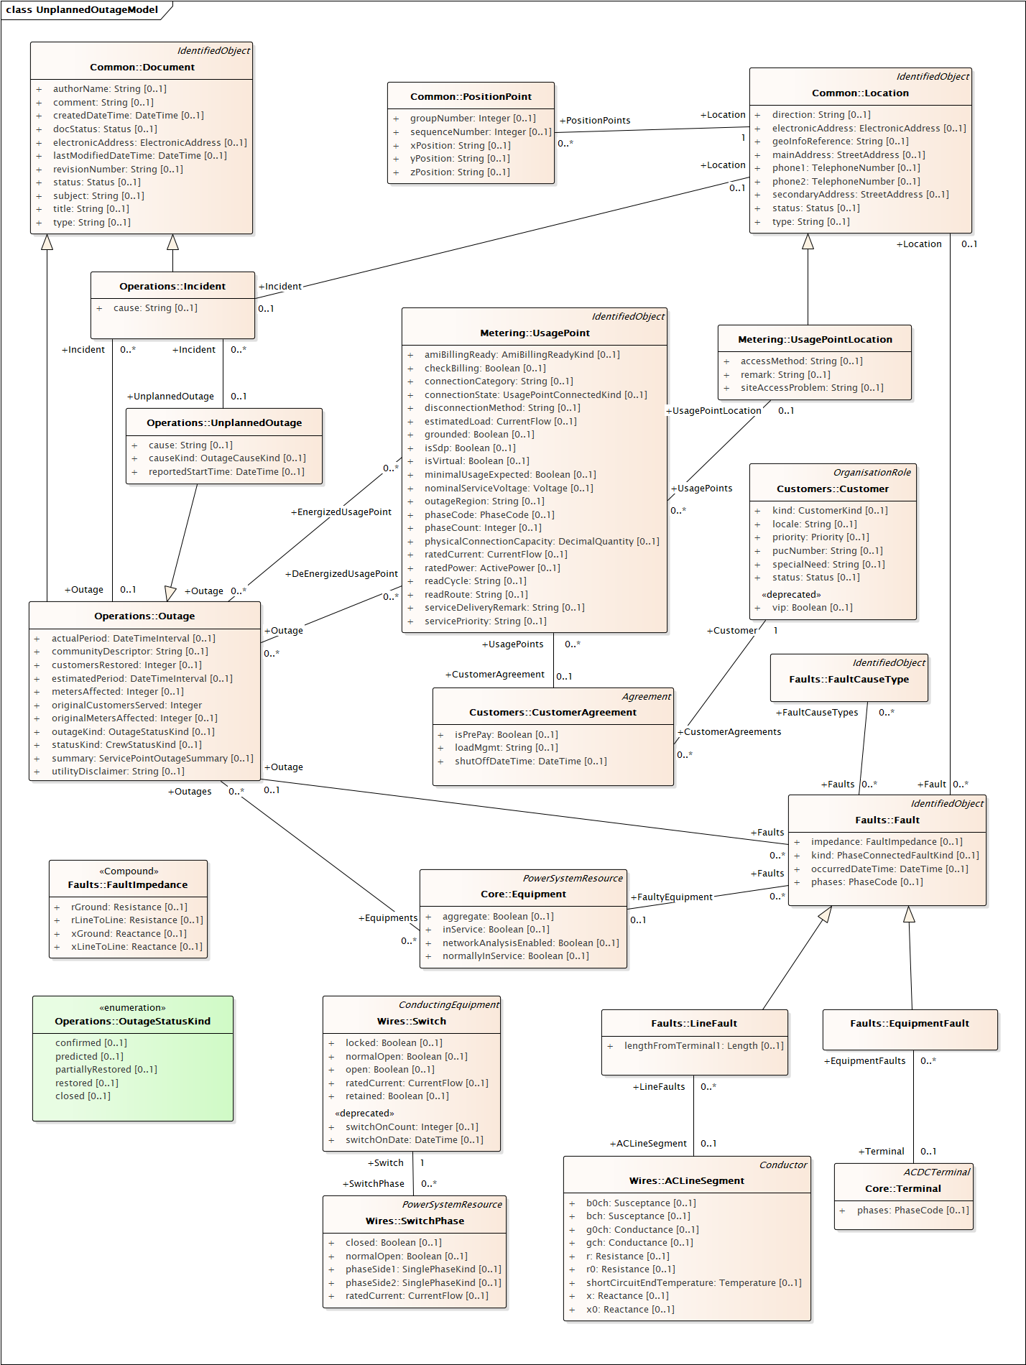

**7.0 Appendix 1: Figures**

Figure 1 – Double circuit transmission corridor

Figure 2 – Message fragment containing the switching device

Figure 3 – Message fragment containing the Outaged Facility for a Line

Figure 4 – Message fragment containing the Outaged Facility for a Transformer

Figure 5 – Message fragment containing the Outaged Facility for a Line with Fault Impedance

Figure 6 – Message fragment containing the Outaged Facility for a Transformer with Fault Impedance